28th Sunday C Cycle homily
Begin with story of the woman begging for justice.
Today, I am that woman begging for justice!
Today is Stewardship Sunday.
Time to again ask for you to share your time, talent, and treasure with the community.

In the story of the Gospel we never hear what is the woman seeking justice for.
But today, I would like to share with you what justice we here at Corpus Christi are seeking,
what our vision of God’s justice is.

I have been developing a vision of justice of our community based on the mission of our parish.
Just what is the mission of our parish?
Developed seven years ago.
1st slide
(Present slide show)
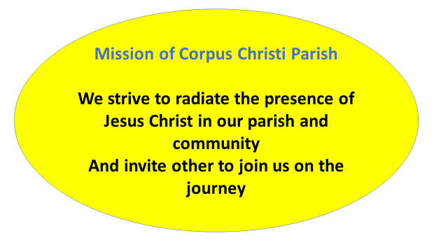

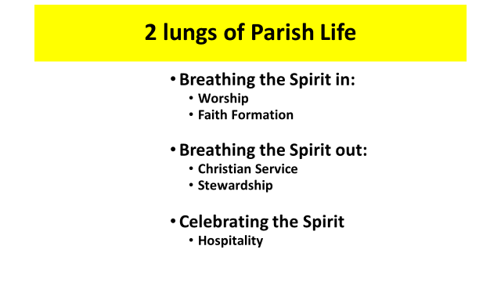
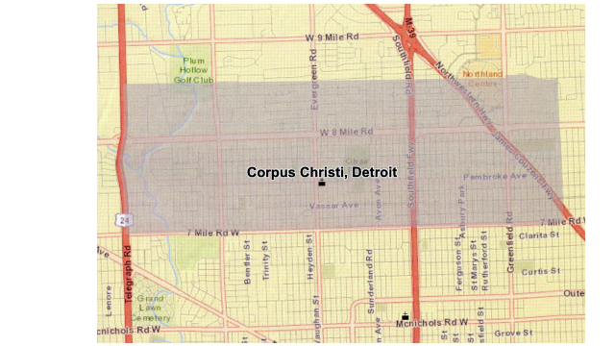

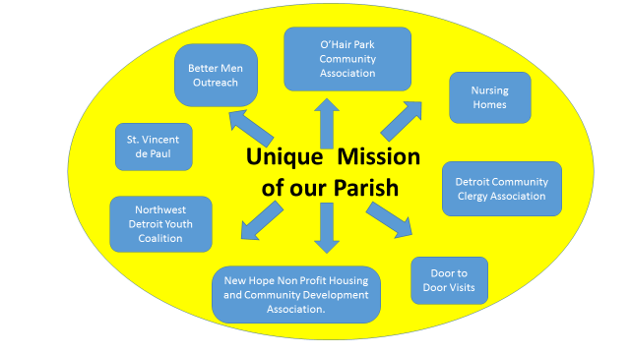

What do we need to do to put flesh on this vision for justice?
First, we need to recall that we are blessed by God. ALL we have is GIFT.
We need to be grateful of all that we have and are. (List of 10 things for which we are grateful.)
Second, respond with a grateful heart by loving God and our neighbor.
(Pass out sheets) They have been passed out for many years. Given personally to each household when they register over the last five years.
Time: prayer
Talent: list of many things; we can all do SOMETHING
Treasure:
Give regularly and generously
- If you give $50 a week (and a number of people do) you may ask if you have been given a raise
- If you give $5 a week, you may ask if you can identify a certain percentage of your income you can give
- If you give irregularly, you may ask if you can give on a regular basis
- We are already $3,000 short
Improvements:
- Parking lot
- Carpeting
- Rainbow Room expansion
- RETURN THEM NEXT WEEK AS PART OF YOUR OFFERING OF YOUR LIVES.

Letter from me in the mail.
Pray with me for justice for our community, neighborhood and world.
All we have is gift graciously given by the Lord.
The gift you have given, give as a gift.

